RTI SALES CHANNEL INFO
RTI Sales Eng./Agency Name |  |  |  |  |  |  |  |  |  |  |  |  |  |  |  |  |  |  |  | 1)Date/Version
 | COMPANY DETAILS
 | 2) Company Name
 | 3) Site Name
 | 4) Site Location / Address
 | 5 Contact Name
 | 6) Email Address |  |  |  |  |  |  |  |  |  |  |  |  |  |  |  | 7) Phone Number
 | MATERIAL INFORMATION
 | 8) General description of the purpose for which the analyser will be used:
 | 9) Material to be Analysed: Coal: Phosphate: Guano: Uranium Ore: Other: Specify Other:
 | 10) Process Status of Material being Conveyed: ROM (Run-of-Mine): Crushed and sized: Washed Product:
 | 11) Conveyer Location (e.g. CHPP Feed, Rejects, TLO etc.)
 | 12) Multi-Seam Operation? |  |  |  |  |  | Yes: No: Seam Type: |  |  |  |  |  |  |  |  |  |  |  |  |  | 13) If Yes, are seams blended? Yes: No:
 | Conveyor / Material Properties |  |  |  |  |  | Min (operating Min - not zero) |  |  |  |  |  |  |  |  | Nominal |  |  |  |  |  |  |  | Max
 | 14) Primary Variable of Interest %
 | 15) Second Variable of Interest %
 | 16) Ash % (if coal)
 | 17 Burden Depth (mm)
 | 18) Particle Size (mm)
 | 19) TPH (tonnes per hour)
 | 20) Belt Loading - Kgs per metre
 | 21) % Fe (Iron) in Ash
 | 22) % Ca (Calcium) in Ash
 | 23) Moisture Analysis Required? |  |  |  |  |  | Yes: No: (If “Yes” request a quotation for a MoistScan Microwave Moisture Analyser )
 | POWER
 | 24) Supply Voltage available |  |  |  |  |  | 240VAC: 115VAC: Other: Specify Other Voltage:
 | 25) Supply Frequency |  |  |  |  |  | 50Hz: 60Hz: |  |  |  |  |  |  |  | 26) Is power regulated? |  |  |  |  |  |  | Yes: No:
 | CONVEYOR DETAILS |  |  |  |  |  | Please provide photographs and drawings of conveyer and indicate the proposed location of the Analyser
 | 27) Belt ID/Name |  |  |  |  |  |  |  |  |  |  |  |  |  |  |  |  |  | 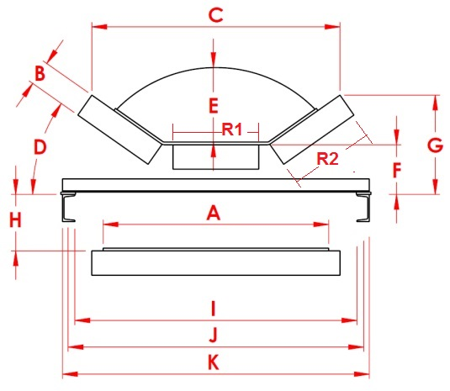  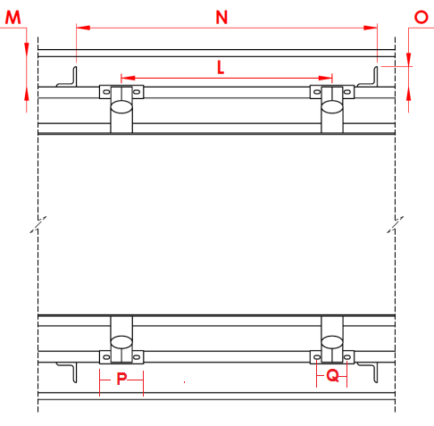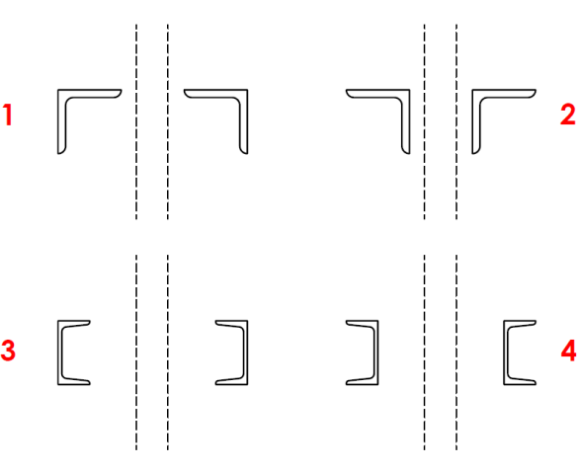
 | 28) Belt Speed (m/sec)
 | 29) Belt Width, Flat (A)
 | 30) Roller Diameter (B)
 | 31) Distance Across Roller Tips (C)
 | 32) Idler Trough Angle (D)
 | 33) Max Material Depth (E)
 | 34) Top of Centre Roller to Top of Stringer (F)
 | 35) Roller Tip to Top of Stringer (G)
 | 36) Distance between Return Belt & Top of Conveyor Stringer (H)
 | 37) Inside – Inside of Stringer (I)
 | 38) Idler Hole Centres, Across conveyor (J)
 | 39) Outside to Outside of Stringer Beams(K)
 | 40) Idler Pitch (L)
 | 41) Stringer to Nearest Existing Structure (M)
 | 42) Stringer Leg Pitch (N)
 | 43) Stringer Leg Width (O)
 | 44) Width of Idler Foot (P)
 | 45) Idler Foot Hole Centres (Q)
 | 46) Roller Face Length (R) | Centre: (R1) Wing: (R2)
 | 47)Type of Idler Frame
 | 48) Stringer Type, Cross Section 1, 2, 3 or 4 ? |  |  |  |  |  |  |  |  | 1: 2: 3: 4: Other:
 | 48a) Other Type, Specify:
 | 49) Desired location of control cabinet,  When viewed in the direction of belt travel? |  |  |  |  |  |  |  |  | Left Side:  Right Side:
 | 50) Distance, Detector Cradle Mounting Foot to proposed position of the control cabinet?
 | 51) Belt Weigher TPH output available? |  |  |  |  |  |  |  |  | Yes: No:
 | 52) Belt Weigher location, relative to proposed analyser location; Upstream or Downstream? |  |  |  |  |  |  |  |  | Up: Down:  Distance: M
 | 53) Rollers per Idler Frame? |  |  |  |  | 3 Rollers: 5 Rollers: Other:
 | 54) Roller Trough Angles/Arc |  |  |  |  | Angle 1: |  |  | Angle 2: |  |  |  |  | Radius:
 | 55) Can the current conveyer structure support the analyser? (approximately 800 kg over 1.0 m) |  |  |  |  |  |  |  |  | Yes: No: |  |  |  |  |  |  |  |  | There are four (4) mounting points for the GammaScan Detector Housing, one at each corner of the Cradle.  I.E. Two per conveyor beam, 1 metre apart.  Approx. Point Loading of 200 Kg.
 | 56) Conveyor Support Frame Type? |  |  |  |  |  |  | Channel: Truss: Cable: Slider Bed: Other:
 | 57) Analyser in Hazardous Zone? |  |  |  |  |  |  | Yes: No: |  |  |  |  | 58) Hazardous Zone Classification:
 | 59) Analyser Tag / Label required |  |  |  |  |  |  | Yes: No: |  |  |  |  | 60) Position of items that run alongside the conveyor stringers? e.g. water/gas pipe, cable tray, emergency pull cable, etc.
Details of items
& their location:
 | 61) Is a mechanical Auto Sampler installed on this belt? |  |  |  |  |  |  |  |  |  |  |  |  |  |  | Yes: No: (If “Y” please answer questions below)
 | 62) Type of Sampler |  |  | 63) Location of Sampler |  |  |  |  |  |  |  |  |  |  |  | 64) Distance from Analyser |  |  |  |  |  |  |  |  | 65) Estimated time lag
 |  |  |  |  |  |  |  |  |  |  |  |  |  |  |  | metres |  |  |  |  |  |  |  |  | seconds
 | ENVIRONMENTAL CONDITIONS
 | 66) Minimum Temp at Analyser location |  |  |  |  |  |  |  |  |  | Degs C |  |  |  |  | 67) Maximum Temp at Analyser Location |  |  |  |  |  |  |  |  |  |  | Degs C
 | COMMUNICATION
 | 68) №: 3/4G wireless signal bars, best signal on site |  |  |  |  |  |  |  |  |  |  |  |  |  |  | 69) №: 3/4G wireless signal bars, at Analyser location
 | 70) Analyser to Pant Communication Type / Protocol |  |  |  |  |  |  |  |  |  | ModBus over TCP/IP: Ethernet /IP: Serial ProfiBus DP: Other:
 | Specify Other:
 | ADDITIONAL DETAILS REQUIRED
 | 71) Where is the analyser to be located? |  |  |  |  |  |  |  |  |  |  | Above Ground:  Below Ground: |  |  |  |  |  | Indoors:  Outdoors: |  |  |  |  | Covered belt & walkway: Yes: No:  Belt Roofing only: Yes: No:
 | 72) Are there any obstructions or metal structures beneath the analyser or between Stringers? |  |  |  |  |  |  |  |  |  |  | Yes: No:  Describe Obstruction:
 | 73) Is the proposed analyser installation location accessible by crane for installation? |  |  |  |  |  |  |  |  |  |  | Yes: No:  Describe Access:
 | 74) Are there any structures that need to be removed before the analyser can be installed? |  |  |  |  |  |  |  |  |  |  | Yes: No:  Provide description:
 | 75) Brand/type/model of plant control system |  |  |  |  |  |  |  |  |  |  | Details  Please:
 | 76) Additional Parameters required? Yes: No: |  |  |  |  |  |  |  |  |  |  | SE (Specific Energy): Other: Specify Other:
 | 77) Any other relevant information to the Specification of or Quotation of the GammaScan Analyser:

